Playing Pitch Strategy Guidance

An approach to developing and delivering a playing pitch strategy

Checklist Document



October 2013

Playing Pitch Strategy Guidance

An approach to developing and delivering a playing pitch strategy

This document presents the checklists for each of the five stages and 10 steps of the approach to developing and delivering a playing pitch strategy. The full guidance document provides detailed advice on how to undertake each stage and individual step.

Stage A: Prepare and tailor the approach (Step 1)
Stage B: Gather information and views on the supply of and demand for provision (Steps 2 & 3)
Stage C: Assess the supply and demand information and views (Steps 4, 5 & 6)
Stage D: Develop the strategy (Steps 7 & 8)
Stage E: Deliver the strategy and keep it robust and up to date (Steps 9 & 10)

Figure 1: Developing and Delivering a Playing Pitch Strategy – The 10 Step Approach

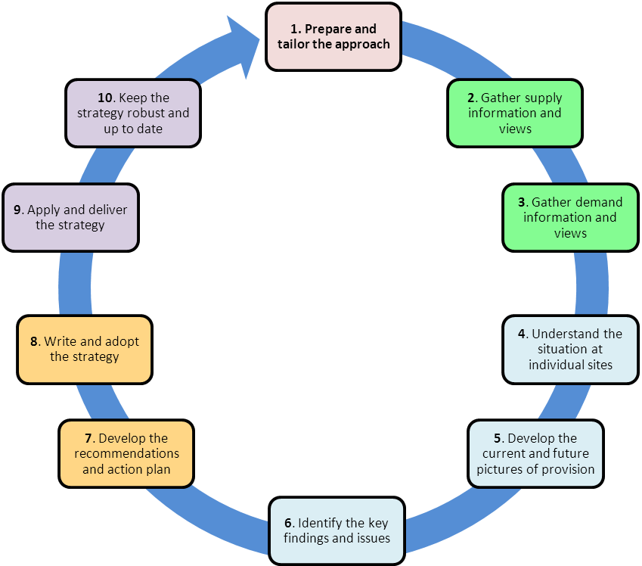
Developing and Delivering a
Playing Pitch Strategy

The 10 Step Approach

Stage A Checklist: Prepare and tailor the approach

Stage A Checklist: Prepare and tailor the approach | Tick 
Stage A Checklist: Prepare and tailor the approach | Yes | Requires Attention
Step 1: Prepare and tailor the approach
- Is it clear why the PPS is being developed (the drivers) and what it seeks to achieve (the benefits)?
- Has the level of support Sport England and each of the main pitch sport NGBs can provide to the particular project been agreed?
- Has an initial scoping meeting been held including all relevant parties?
- Has a steering group been established to lead the work and is it representative of the drivers behind the work and providers and users of pitches in the area?
- Has a partnership approach been developed and has it been confirmed what support, advice and/or resources each party can bring to the work?
- Has the study area been defined and agreed by all relevant parties and have any known cross boundary issues been highlighted?
- Has high level officer and political support been secured and are such relevant individuals part of the steering group?
- Has a vision for pitch provision for the study area been developed alongside specific objectives and is there agreement on how far forward the PPS should look?
- Has a strong project team been established which is supported by adequate resources and has the necessary skills to develop the PPS?
- Has a realistic project plan been agreed by the steering group and the NGBs which sets out the overall timescale and when elements of the work will be undertaken?
- Has some thought been given to how the work will be structured and presented?
- Have any features which make the study area different been identified along with the impact they may have on pitch provision and the approach to the PPS?
- Has an understanding been developed of how the population participates in sport and what this may mean for pitch provision now and in the future?
- Alongside the main pitch sports has the inclusion of other pitch sports been considered and is there agreement on which should be included in the PPS?
- Is it clear how the sports to be included are governed in the area, what the league structure is and how this can help with developing the PPS?
- Has an indication been provided on the potential nature of any sub areas, do they represent how the sports are played in the study area and will these be reviewed once relevant information is gathered during Stage B?
- Has a strong, locally specific and tailored brief been developed which builds in the work undertaken to prepare the approach to developing the PPS?
- Have the project brief and project plan been signed off by the steering group?
- If external consultancy support is to be procured is this to be done after Stage A is complete but before work on Stage B commences?

Stage B Checklist: Gather supply and demand information and views

Stage B Checklist: Gather supply and demand information and views | Tick
 | Yes | Requires Attention
Step 2: Gather supply information and views
- Has the Active Places Power PPS Audit Report been run to help develop the audit?
Does the project team know...
- The name, reference and location details for each site?
- Who owns and manages each site?
- The number and type of pitches on each site (by sport and age group)?
- The age and surface type of AGPs and the types of play they can accommodate?
- How available each pitch is to the local community and for those that are available how secure the community use is?
- The cost of hiring/leasing pitches in the study area across ownership and management categories, quality ratings and within neighbouring areas?
- The quality of all pitches and ancillary facilities and have initial quality ratings been checked with by steering group and NGBs and subsequently agreed?
- How the pitches are maintained and whether there are any issues with, or proposals to amend, the current maintenance regime and/or arrangements?
- What the current level of protection is for all sites (e.g. planning policy), which are afforded any other particular protection (e.g. deeds of dedication) and if there are any issues with the security of tenure and any sites?
- What the views of users and other parties are on the adequacy of provision at individual sites and as a whole within the study area?
Step 3: Gather demand information and views – Does the project team know…
- All the sports clubs that use pitches in the study area, the number and nature of teams they run and where and when they play matches and train?
- Of any casual use or other demand taking place at sites in the study area?
- The pitch sites educational and other such establishments use and whether this provision is adequate to meet their current and future needs?
- Where and when any educational (and other similar) establishments use provision over and above their own (i.e. external sites) and how secure any such use is?
- Whether educational establishments feel they have any spare capacity for community use at their sites?
- The nature and extent of displaced demand, the reasons for this, where it is currently met, whether those generating it would rather play in the study area?
- The nature and extent of any unmet and latent demand?
- Whether there are any key trends and changes in the demand for pitches?
- All the necessary information to allow for an estimate to be developed of the likely future demand for playing pitches?
Collating and presenting the supply and demand information
- Is the supply and demand information collated into a single document allowing the viewer to sort the information by key areas (i.e. by site, sport and pitch type)?
- Within the single document have all types of current demand, wherever possible, been allocated to the site where the play takes place?
- Have the steering group and NGBs had the opportunity to check and challenge the audit information?

Stage C Checklist: Assess the supply and demand information and views

Stage C Checklist: Assess the supply and demand information and views | Tick
 | Yes | Requires Attention
Step 4: Understand the situation at individual sites
- Have overviews been developed for all sites available to the community? Do they:
1a. Present the findings of the comparison work for each relevant pitch type?
1b. Indicate whether there is any spare capacity, including during the peak period for football, rugby union and rugby league pitches and for hockey matches on the peak day?
1c. Set out the key issues and views with the provision at the site and its use?
- Is it clear how much play a site can accommodate in the relevant comparable unit (its current carrying capacity for community use) for each pitch type it contains? In doing has the work:
2a. Used the agreed quality ratings and NGB guidance for natural grass pitches?
2c. Set out the current carrying capacity per surface type for AGPs?
2c. Ensured the suggested carrying capacity has been adjusted where appropriate to reflect:
- Use by the educational establishment of their site where it is available to the community
- Other local information and views.
- Is it clear how much play takes place at a site for each pitch type it contains? In doing so has the work:
3a. Built in all relevant sports club play (matches and training), casual and other use of a site, along with any educational use of external sites?
3b. Ensured play taking place on a pitch dedicated for a different type of play/age range, on a pitch marked out over another pitch, or at a central venue has been captured?
3c. Provided a total of the hours in the peak period each AGP is used but also broken this down by the sports and types of play that that takes place there?
3d. Made a record of any use of a site which is difficult to quantify and/or allocate to a particular site?
- Has the project team presented and checked whether it is appropriate to record any identified potential to accommodate additional play at a site as spare capacity?
- Have the site overviews been presented in a way which allows them to be sorted and filtered by key fields to aid the further assessment work?
- Have the NGBs and other stakeholders been given the opportunity to review the site overviews?
Step 5 (part): Develop the current picture of provision
- Has an overview been provided of the current situation across:
- All sites available to the community; and
- Only those with secured community use?
- Do the overviews indicate whether (and outline to what extent) provision is on balance being overplayed, is at capacity or whether some spare capacity exists?
- Do the overviews provide the situation during the peak periods and throughout the week for football, rugby union and rugby league pitches, as well as for hockey matches on the peak day?
- Has the total number, nature and location of sites which may be overplayed or where spare capacity exists been presented?
- Has the extent and location of any spare capacity for football, rugby union and rugby league pitches during the peak period, along with for hockey matches on the peak day, been presented?
- Has the extent, nature and location of demand currently taking place at unsecured sites been presented along with any sports and types of play that are heavily reliant on such sites?
- Has the extent, nature, location and reason for any displaced, unmet and latent demand been presented?
- Have the key issues and views with the adequacy of current provision been presented along with the situation at priority sites?
Step 5 (part): Develop the future picture of provision
- Is it clear to what extent future population change may affect the demand for provision across all pitch types?
- Has the potential impact of relevant aims and objectives for increasing participation, along with current trends and predicted changes in how the pitch sports are played and pitches used, been presented and justified?
- Are particular and key sports clubs and/or sites where demand is likely to increase in the future highlighted? Is the nature and extent of this future demand presented along with the ability for it to be met by current provision?
- Have any forthcoming known changes in the supply of provision been presented along with how they may affect the adequacy of provision to meet demand?
- Has an indication been provided for each pitch type of what extent future demand may be met by:
- The current provision available to the community; and
- By only those current sites with secured community use?
- Do the above indications present the potential situation during the peak period and throughout the rest of the week for natural grass football, rugby union and rugby league pitches, as well as for hockey matches on the peak day?
- Have the steering group reviewed the assessment work and discussed what the key findings and issues may be?
Step 6: Identify the key findings and issues
- Have the key findings and issues been clearly presented and used to help answer the following questions?
1a. What are the main characteristics of the current supply of and demand for provision?
1b. Is there enough accessible and secured community use provision to meet current demand?
1c. Is the provision that is accessible of sufficient quality and appropriately maintained?
1d. What are the main characteristics of the future supply of and demand for provision?
1e. Is there enough accessible and secured community use provision to meet future demand?
2. Has the likely nature of any actions that will be required to ensure provision can meet both current and future demand been presented?
- To help highlight and present the key findings and issues has reference been made to the situation at particular sites and geographic locations for each sport, and have appropriate maps and other visual tools been used?
- Have the assessment details, along with key findings and issues, been agreed by the steering group and presented in a suitable format?

Stage D Checklist: Develop the Strategy

Stage D Checklist: Develop the Strategy | Tick
Stage D Checklist: Develop the Strategy | Yes | Requires Attention
Step 7: Develop the recommendations and action plan
- Have a number of study area specific scenarios been looked at to help explore key issues and findings along with possible recommendations and actions?
- Have any recommendations and actions regarding AGP provision taken into account the guidance in the ‘Selecting the Right Artificial Surface’ document and any NGB specific information?
- Do the recommendations reflect the drivers, vision and objectives of the work?
- Are the recommendations precise enough to enable the development of clear individual area, sport and site specific actions to help achieve them?
- Have all relevant parties been engaged with the development of, and are signed up to the delivery of, the recommendations and actions?
- Are the recommendations and actions clearly presented?
- Has particular attention been paid to the situation at priority sites and those which are being significantly overplayed?
- Have area, sport and site specific solutions been proposed to protect, enhance, and provide playing pitch provision to meet the current and future demand?
- Has guidance on the future of any sites highlighted as being at risk been provided?
- Do the recommendations and actions seek to make the best use of existing pitches?
- Has the detriment and benefit of proposals to relocate provision been presented?
- Has the level and type of any new playing pitch provision required been presented?
- Has the importance of providing appropriate and fit for purpose ancillary facilities been highlighted in order to maximise the potential benefit to sport of any pitches?
- Have the recommendations sought to ensure an adequate amount of spare capacity in the provision of accessible pitches with secured community use?
- Does the PPS provide a steer as to the future of any spare capacity and any provision that may be genuinely surplus to requirements (paragraphs D12 to D15)?
- Does the action plan cover the points listed in paragraph D17?
- Does the action plan provide the most appropriate actions to improve provision in the study area rather than just those which the local authority can deliver?
- Does the action plan represent an infrastructure plan for playing pitches with deliverable area, sport and site specific actions and projects?
Step 8: Write and Adopt the Strategy
- Does the PPS document provide the reader with a clear understanding of the areas listed in paragraph D20?
- Is it clear from the PPS document why the recommendations and actions have been included, how they are to be delivered and what they will achieve?
- Does the PPS document indicate how it should be used and applied in different areas and circumstances along with the benefits of doing so?
- Has the PPS document been subject to appropriate consultation?
- Do all members of the steering group and other relevant parties endorse the PPS and recognise its lead role in guiding the improvement of pitches in the study area?
- Has the PPS document been formally adopted by the local authority and is its status recognised across all relevant departments?

Stage E Checklist: Deliver the strategy and keep it robust and up to date

Stage E: Deliver the strategy and keep it robust and up to date | Tick
 | Yes | Requires Attention
Step 9: Apply & deliver the strategy
- Are steering group members clear on how the PPS can be applied across a range of relevant areas?
- Is each member of the steering group committed to taking the lead to help ensure the PPS is used and applied appropriately within their area of work and influence?
- Has a process been put in place to ensure regular monitoring of how the recommendations and action plan are being delivered and the PPS is being applied?
Step 10: Keep the strategy robust & up to date
- Has a process been put in place to ensure the PPS is kept robust and up to date?
- Does the process involve an annual update of the PPS?
- Is the steering group to be maintained and is it clear of its on-going role?
- Is regular liaison with the NGBs and other parties planned?
- Has all the supply and demand information been collated and presented in a format (i.e. single document that can be filtered accordingly) that will help people to review it and highlight any changes?
- Have any changes made to the Active Places Power data been fed back to Sport England?

