Assessing Needs and Opportunities Guide for Indoor and Outdoor Sports Facilities
How to undertake and apply needs assessments for
sports facilities
Checklist


July 2014
Assessing Needs and Opportunities Guide for Indoor and Outdoor Sports Facilities

How to undertake and apply needs assessments for sports facilities

This document presents the checklists for each of the three stages approach to undertaking a needs assessment for sport facilities. The full guidance document provides detailed advice on how to undertake each stage and individual step.

Stage A: Prepare and tailor the approach
Stage B: Gather information on Supply and Demand
Stage C: Assessment –Bring the Information Together

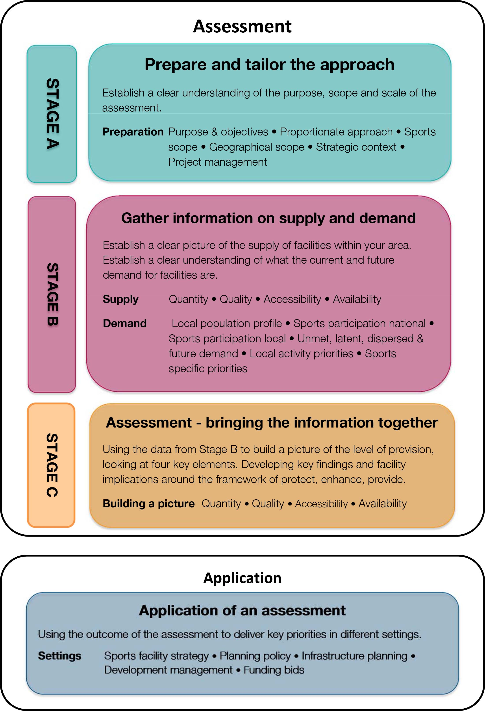

Stage A: Prepare and Tailor the Approach - checklist

At the end of this Stage A you should be able to answer the following questions. If you cannot, you may need to revisit these areas before moving to the next stage.

Stage A : Prepare and tailor the approach | Tick 
Stage A : Prepare and tailor the approach | Yes | Requires Attention
Purpose and objectives
- Do you know why the assessment is being undertaken (drivers)?
- Is there a clear understanding as to how the findings of the assessment, once it is completed, will be used?
- Is there a clear purpose and focus to the work?
- Is it clearly articulated what the assessment is seeking to achieve?
- Have a clear set of objectives been developed?
- Is there a clear time horizon the assessment will look to?
- Are you including future needs?
Proportionate
- Is the scale and scope of the assessment proportionate to its intended use?
Sports Scope
- Is it clear what sports facilities you are including?
- Is it clear why you are including specific facilities and are they linked to achieving your objectives?
- Are you clear what sports are the most popular in your area?
- Have you contacted the NGB’s? See Appendix 2.
- Have you contacted community sports representatives?
- Do the NGB’s have priorities within your area?
- Are you clear on the level of play of specific sports within you area?
- Are you including facilities for the most important sports within your area?
Geographical Scope
- Does your study area reflect the catchment areas of the different facilities included within the assessment?
- Have you considered joint working with neighbouring LA’s for facilities with cross boundary catchments?
- Have you considered dividing your area into appropriate sub areas for specific facilities?
- Are you clear on the catchments of any specialist sports facilities within your area?
- Are you clear on the specific modes of travel for different types of facilities?
Strategic Context
- Is it clear how the assessment sits with the LA’s strategic context?
- Do the objectives of the assessment fit with the LA’s corporate priorities and/or any high level visioning documents?
- Are you clear on the strategic drivers in the area and how they influence the assessment?
- Have you considered any national sports policies that may impact on your assessment?
- Have you considered any NGB Facility Strategies that could have implications for your area, or facilities you are including?
- Have you considered any village or neighbourhood plans that may identify local facility priorities?
Project management
- Is there a clear project manager?
- Is there a clear project brief and project plan?
- Is the project team made up of appropriate representatives, for example all relevant internal LA departments for a district wide study?
- Has the project got senior officer and member support?
- Is it clear who the external stakeholders will be?
- Have the relevant NGB contacts been identified locally and nationally?
- Have you confirmed and agreed the level of support, timescales and input to be provided by external stakeholders?

Stage B: Gathering the supply and demand information – checklist

At the end of this Stage B you should be able to answer the following questions. If you cannot, you may need to revisit these areas before moving to the next stage.

Stage B : Gather Information on supply and demand | Tick
Stage B : Gather Information on supply and demand | Yes | Requires attention
Supply information
- Have you included facilities provided by all sectors, such as, education, club, and commercial? Have you considered cross-boundary issues?
- Have you included any planned facilities that you know about?
- Do you know how many facilities are within the area?
- Have you considered the capacity of facilities, and not just a simple facility count?
- Have you collected information on the overall condition of facilities? Have you used feedback from user surveys and facility managers to help with this?
- Have you considered if the facilities are fit for purpose to meet the levels of play for specific sports? Have you contacted the NGB’s to help with this?
- Have any facilities used national quality schemes (NBS/Quest) to help with comparisons and is this information captured?
- Do you have local usage data that can help in establishing travel times and catchments for facilities?
- Are there any factors that require different catchments for the same facility type, such as urban/rural split?
- Have you mapped your facilities using your catchments?
- Have you a clear picture of how busy the facilities are? How the facilities are being programmed and managed?
- Are there any management programming issues that impact on the availability of specific facilities?
Demand information
- What is the current and future demographic and socio-economic profile of your area?
- Are you clear on what the demands are for sports and activities within your area? What does both national and local participation data say for your area?
- Is there any indication of unmet and latent demand for specific facilities or activities?
- Is there any indication that current demand and usage is being displaced to facilities outside your area and if so, are you clear why this is?
- Has information been gathered on the potential future demand in the area including trends and changes, population projections and feedback from sports clubs and other users?
- Are there any local priorities and targets for specific activities that will create new or additional demand?
- Have the NGB’s, or other parties identified any specific targets for particular sports that will create new or additional demands within your area?
Consultation
- Are there any existing user surveys that you can utilise?
- Have you identified and consulted with key user groups and providers?
- Have you contacted the NGBs (see Appendix 2), and CSP’s?
- Have you contacted local sports clubs?
- Have you ensured the consultation techniques/formats area tailored to the groups /users you are trying to contact?

Stage C checklist: Bringing the information together | Tick
Stage C checklist: Bringing the information together | Yes | Requires attention
Quantity
- How many facilities are there?
- How are facilities being used? Are they generally busy/full or is there spare capacity?
- Are there any issues that impact on the use of the facility
- Are specific facilities experiencing high levels of usage at certain times of the day and on certain days of the week?
- Are all facilities full or are some busier than others?
- What are the possible reasons for these observations and what does it tell you?
Quality
- Does the quality of facilities meet the standard required or desired by the user? If not, are there any specific facilities this affects?
- Is provision appropriate to meet the relevant NGB standard of play and competition? If not, what is the impact?
- How is quality a factor in attracting or discouraging participation and usage?
Accessibility
- How does accessibility affect the way in which facilities are being used (or not used)?
- Can demand physically travel to the current facility stock? Are there specific geographic areas where accessibility is having a significant effect on usage?
- Is accessibility a reason why certain facilities are busy while others may have spare capacity?
- How do accessibility issues build on any initial thoughts on whether the number and size of facilities is sufficient?
- In addition to the number and size of facilities therefore – are they in the right place and is there appropriate coverage?
- If there are ‘gaps’ in provision – is there sufficient untapped demand to justify new provision or are there other alternatives to think about?
Availability
- Are there restrictions on some facilities that affect their availability? How does this impact on the supply and demand relationship?
- Does the price of using certain facilities affect how they are used?
- Are opening times or programming of sessions an important factor in understanding the supply & demand picture?
- Does ownership and management affect the availability of facilities to users, or specific groups?
- Are there identifiable issues that impact on the capacity and availability of facilities for all potential users and/or specific groups?
- How do availability issues help to clarify the picture you are building of your local area?
Key findings and monitoring
- Have you presented the key findings in a report?
- Have the key findings been checked and challenged with stakeholders?
- Has ongoing monitoring and review been given consideration?

